React Native or Flutter installation

-------------------------------------------

1. Install node, npm
2. Android studio - downloads & install
3. 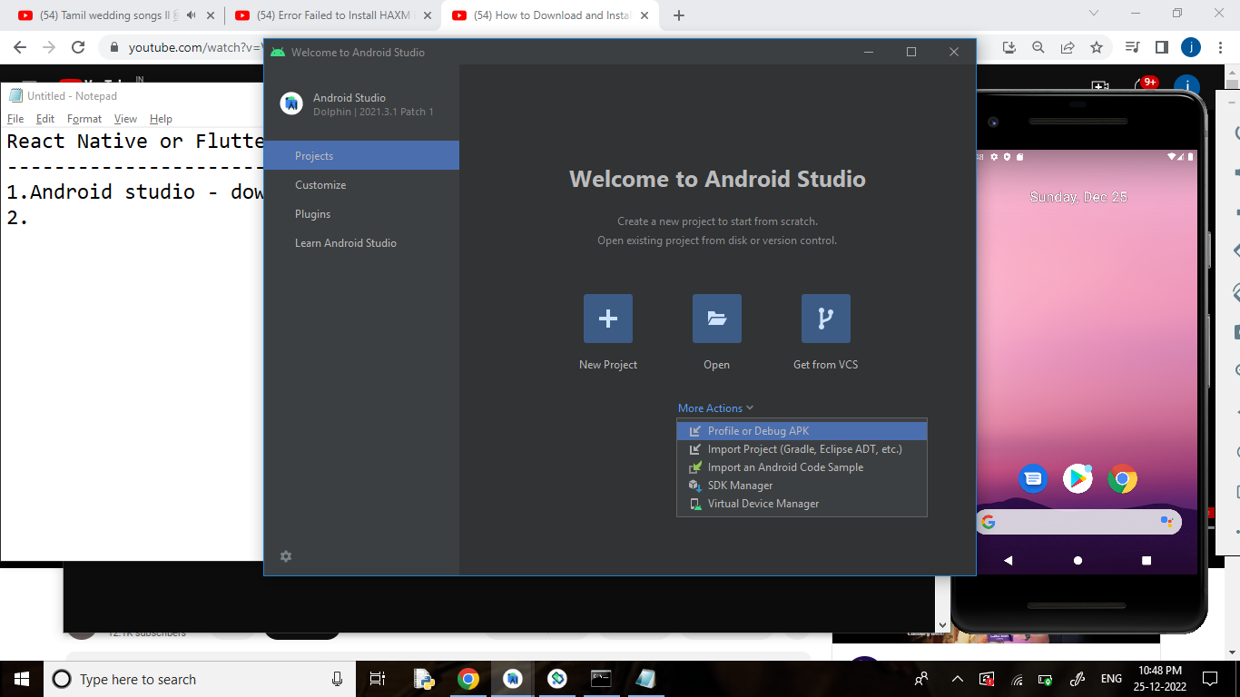Install virtual device manager
4. Verify HAXN – virtual environment enable[bios setup, task manager]
5. Install and create project using expo-cli [React native commands]
6. Run the project -> npm start